Assignment 4

1. Heart Start produces automated external defibrillators (AEDs) in each of two different plants (A and B). The unit production costs and monthly production capacity of the two plants are indicated in the table below. The AEDs are sold through three wholesalers. The shipping cost from each plant to the warehouse of each wholesaler along with the monthly demand from each wholesaler are also indicated in the table. How many AEDs should be produced in each plant, and how should they be distributed to each of the three wholesaler warehouses so as to minimize the combined cost of production and shipping?

*Unit Shipping Cost Unit Monthly*

|  |  |  |  |  |  |
| --- | --- | --- | --- | --- | --- |
|  | *Warehouse 1* | *Warehouse 2* | *Warehouse 3* | *Production Cost* | *Production Capacity* |
| *Plant A* | *$22* | *$14* | *$30* | *$600* | *100* |
| *Plant B* | *$16* | *$20* | *$24* | *$625* | *120* |
| *Monthly Demand* | *80* | *60* | *70* |  |  |

Formulate and solve this transportation problem using *lpsolve*, or any other equivalent library in R.

## **Solution:**

Assigning variables to the given data

**/* Plant A Warehouse 1 = X1 */**

**/* Plant A Warehouse 2 = X2 */**

**/* Plant A Warehouse 3 = X3 */**

**/* Plant B Warehouse 1 = X4 */**

**/* Plant B Warehouse 2 = X5 */**

**/* Plant B Warehouse 3 = X6 */**

/* As demand and supply aren’t equal, to solve in transportation method we are adding **2 dummy variables** in order to match the demand and supply*/

**Min M = 622 X1 + 614 X2 + 630 X3 + 641 X4 + 645 X5 + 649 X6 + 0 X7 + 0 X8**

**/* Demand Constraints */**

**X1 + X4 = 80**

**X2 + X5 = 60**

**X3 + X6 = 70**

**X7 + X8 = 10**

**/* /Supply Constraints */**

**X1 + X2 + X3 + X7 = 100**

**X4 + X5 + X6 + X8 = 120**

Where **Xi**≥ 0 (where i = 1,2,3,4,5,6 – Declared above)

1. **Oil Distribution** Texxon Oil Distributors, Inc., has three active oil wells in a west Texas oil field. Well 1 has a capacity of 93 thousand barrels per day (TBD), Well 2 can produce 88 TBD, and Well 3 can produce 95 TBD. The company has five refineries along the Gulf Coast, all of which have been operating at stable demand levels. In addition, three pump stations have been built to move the oil along the pipelines from the wells to the refineries. Oil can flow from any one of the wells to any of the pump stations, and from any one of the pump stations to any of the refineries, and Texxon is looking for a minimum cost schedule. The refineries’ requirements are as follows.

Refinery

R1

R2

R3

R4

R5

Requirement

(

TBD

)

30

57

48

91

48

The company’s cost accounting system recognizes charges by the segment of pipeline that is used. These daily costs are given in the tables below, in dollars per thou- sand barrels.

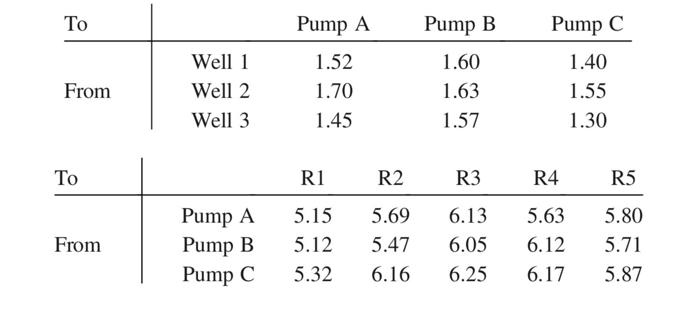

* 1. What is the minimum cost of providing oil to the refineries? Which wells are used to capacity in the optimal schedule? Formulation of the problem is enough.

## **Solution**:

Formulating from the given:

|  |  |  |  |  |
| --- | --- | --- | --- | --- |
|  | **Pump A** | **Pump B** | **Pump C** | **Capacity-TBD** |
| **Well 1** | 1.52 | 1.60 | 1.40 | 93 |
| **Well 2** | 1.70 | 1.63 | 1.55 | 88 |
| **Well 3** | 1.45 | 1.57 | 1.30 | 95 |
| **R1** | 5.15 | 5.12 | 5.32 | 30 |
| **R2** | 5.69 | 5.47 | 6.16 | 57 |
| **R3** | 6.13 | 6.05 | 6.25 | 48 |
| **R4** | 5.63 | 6.12 | 6.17 | 91 |
| **R5** | 5.80 | 5.71 | 5.87 | 58 |

Pumps = (PA, PB, PC); Wells = (W1, W2, W3); Refineries = (R1, R2, R3, R4, R5)

**Min, M = 1.52 PAW1 + 1.60 PBW1 + 1.40 PCW1 + 1.70 PAW2 + 1.63 PBW2 + 1.55 PCW2 +1.45 PAW3 + 1.57 PBW3 + 1.30 PCW3 + 5.15 PAR1 + 5.12 PBR1 + 5.32 PCR1 + 5.69 PAR2 + 5.47 PBR2 + 6.16 PCR2 + 6.13 PAR3 + 6.05 PBR3 + 6.25 PCR3 + 5.63 PAR4 + 6.12 PBR4 + 6.17 PCR4 + 5.80 PAR5 + 5.71 PBR5 + 5.87 PCR5**

Well Constraints – Supply

**PAW1 + PBW1 + PCW1 = 93**

**PAW2 + PBW2 + PCW2 = 88**

**PAW3 + PBW3 + PCW3 = 95**

Refinery Constraints – Demand

**PAR1 + PBR1 + PCR1 = 30**

**PAR2 + PBR2 + PCR2 = 57**

**PAR3 + PBR3 + PCR3 = 48**

**PAR4 + PBR4 + PCR4 = 91**

**PAR5 + PBR5 + PCR5 = 48**

**PARD + PBRD + PCRD = 2**

/* As demand and supply are not equal, we added **dummy variables** in order to match the demand and supply*/

**PAW1 + PBW1 + PCW1 = PAR1 + PAR2 + PAR3 + PAR4 + PAR5 + PARD**

**PAW2 + PBW2 + PCW2 = PBR1 + PBR2 + PBR3 + PBR4 + PBR5 + PBRD**

**PAW3 + PCW3 + PCW3 = PCR1 + PCR2 + PCR3 + PCR4 + PCR5 + PCRD**

Where, PWR ≥ 0 ; Pumps = (PA,PB,PC); Wells = (W1,W2,W3) ; Refineries = (R1,R2,R3,R4,R5,R6)

* 1. Show the network diagram corresponding to the solution in (a). That is, label each of the arcs in the solution and verify that the flows are consistent with the given information.

## **Solution:**

Oil Distribution Network

Optimal Solution Network Diagram

